**Amazon CloudWatch**

[**Amazon CloudWatch**](https://aws.amazon.com/cloudwatch/) is a web service that enables you to monitor and manage various metrics and configure alarm actions based on data from those metrics.

**CloudWatch alarms**

With CloudWatch, you can create [**alarms**](https://docs.aws.amazon.com/AmazonCloudWatch/latest/monitoring/AlarmThatSendsEmail.html) that automatically perform actions if the value of your metric has gone above or below a predefined threshold.

**CloudWatch dashboard**

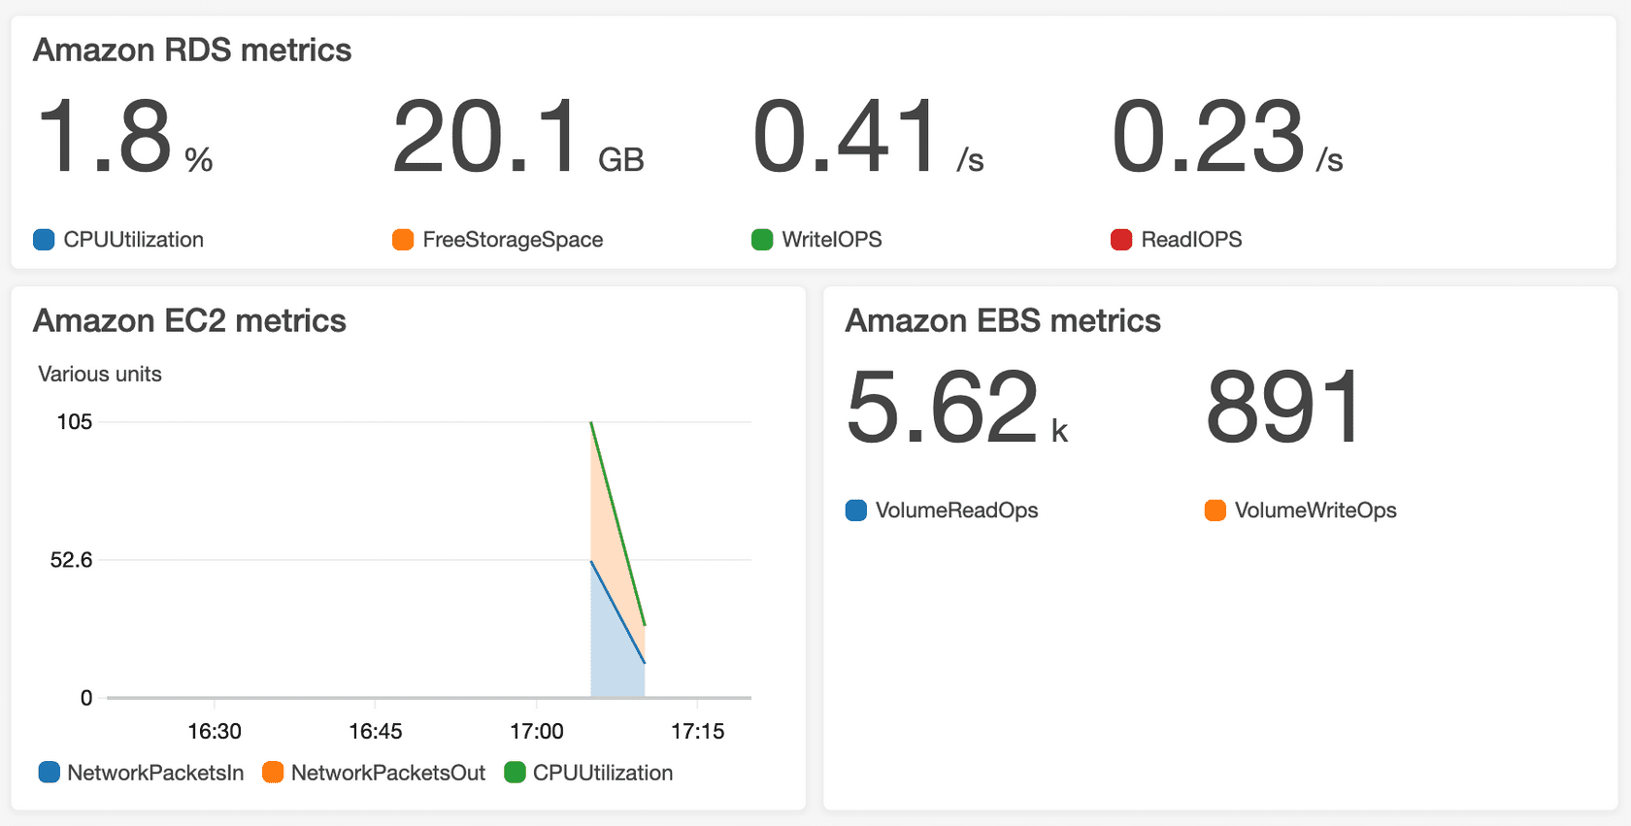

The CloudWatch [**dashboard**](https://docs.aws.amazon.com/AmazonCloudWatch/latest/monitoring/CloudWatch_Dashboards.html) feature enables you to access all the metrics for your resources from a single location. For example, you can use a CloudWatch dashboard to monitor the CPU utilization of an Amazon EC2 instance, the total number of requests made to an Amazon S3 bucket, and more. You can even customize separate dashboards for different business purposes, applications, or resources.

**AWS CloudTrail**

[**AWS CloudTrail**](https://aws.amazon.com/cloudtrail/) records API calls for your account. The recorded information includes the identity of the API caller, the time of the API call, the source IP address of the API caller, and more. You can think of CloudTrail as a “trail” of breadcrumbs (or a log of actions) that someone has left behind them.

**Example: AWS CloudTrail event**

Suppose that the coffee shop owner is browsing through the AWS Identity and Access Management (IAM) section of the AWS Management Console. They discover that a new IAM user named Mary was created, but they do not know who, when, or which method created the user.

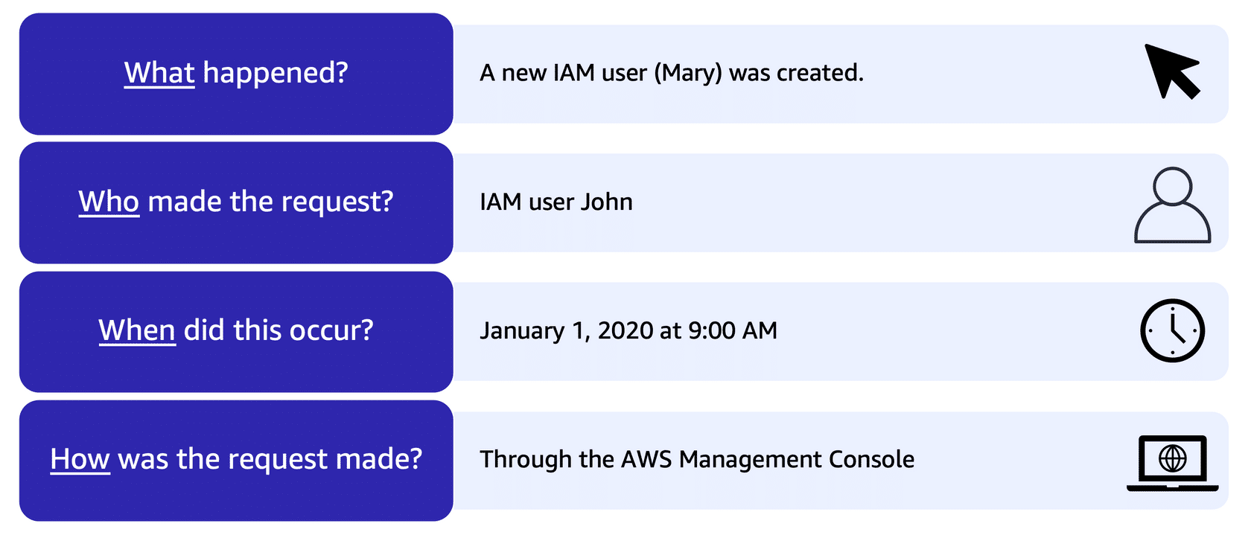

**CloudTrail Insights**

Within CloudTrail, you can also enable [**CloudTrail Insights**](https://docs.aws.amazon.com/awscloudtrail/latest/userguide/logging-insights-events-with-cloudtrail.html). This optional feature allows CloudTrail to automatically detect unusual API activities in your AWS account.

**AWS Trusted Advisor**

[**AWS Trusted Advisor**](https://aws.amazon.com/premiumsupport/technology/trusted-advisor/) is a web service that inspects your AWS environment and provides real-time recommendations in accordance with AWS best practices.

**AWS Trusted Advisor dashboard**

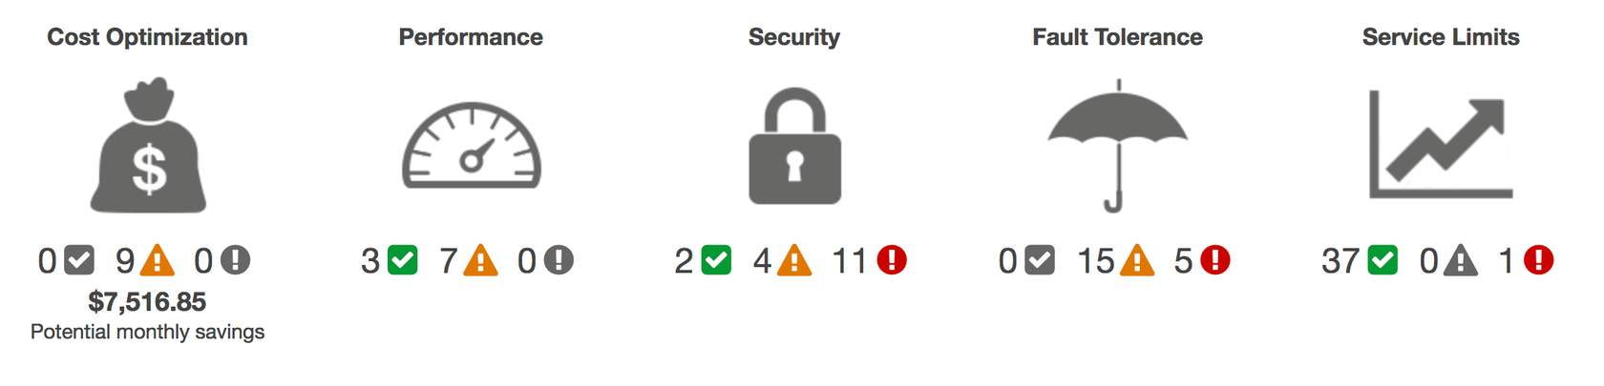

For each category:

* bullet

The green check indicates the number of items for which it detected **no problems**.

* bullet

The orange triangle represents the number of recommended **investigations**.

* bullet

The red circle represents the number of recommended **actions**.